L

1. 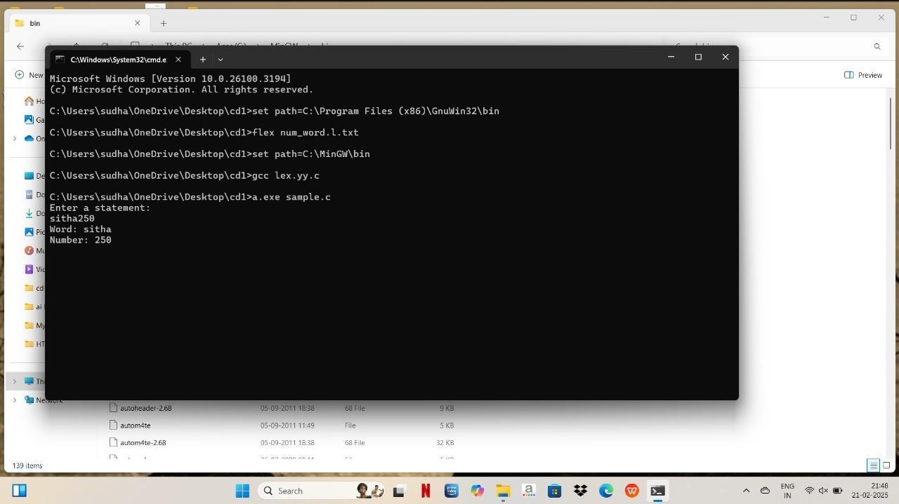Write a LEX program to recognise numbers and words in a statement. Pooja is a small girl of age 3 always fond of games. Due to the pandemic, she was not allowed to play outside. So her mother designs a gaming event by showing a flash card. Pooja has to separate the numbers in one list and words in another list shown in the flash card.
2. Write a LEX program to identify and count positive and negative numbers.

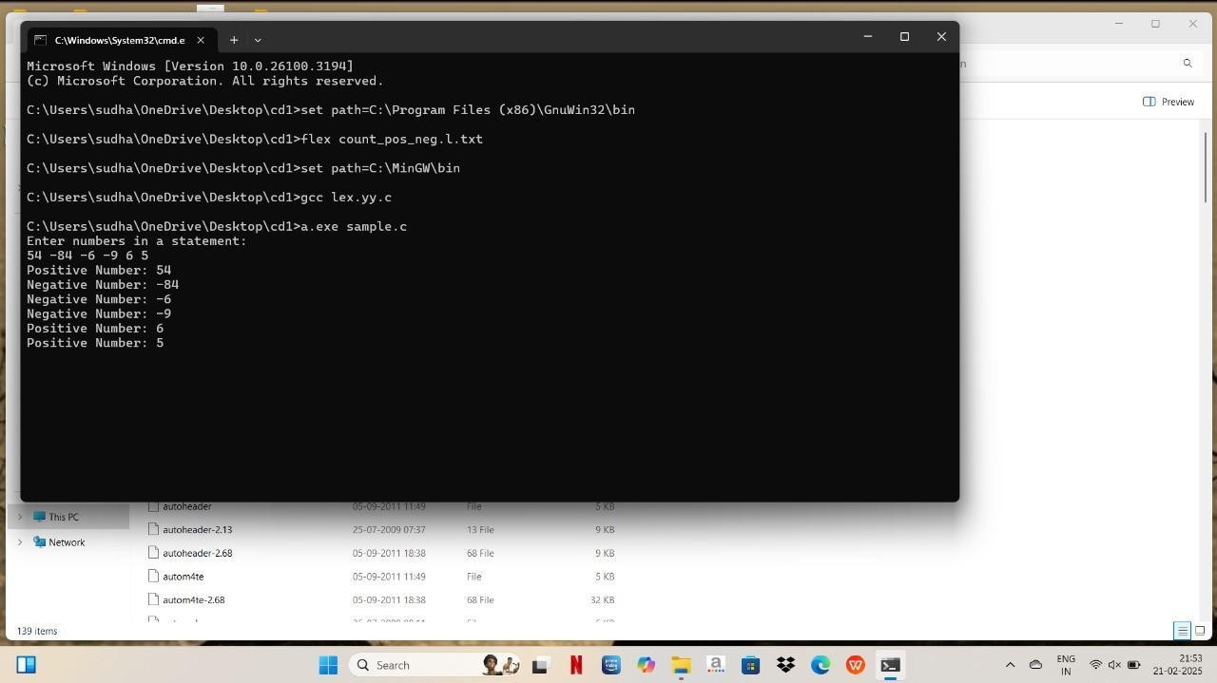

1. 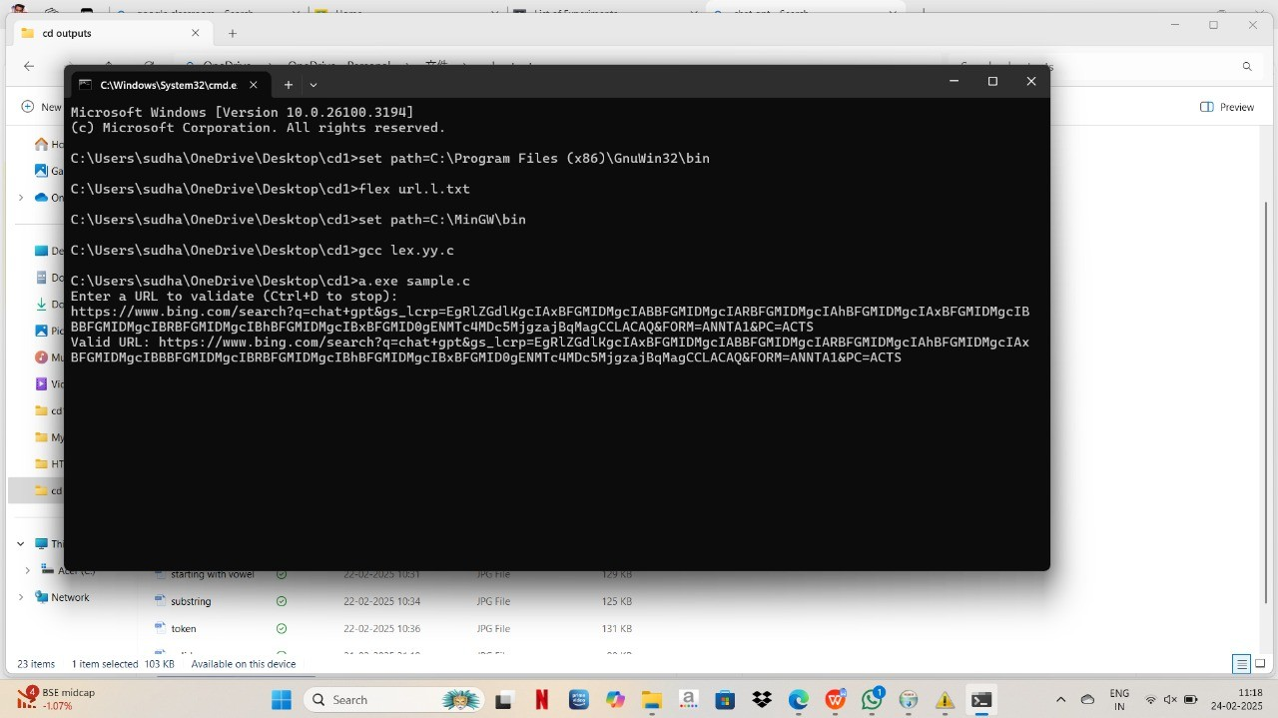A networking company wants to validate the URL for their clients. Write a LEX program to implement the same.
2. School management wants to validate DOB of all students. Write a LEX program to implement it.

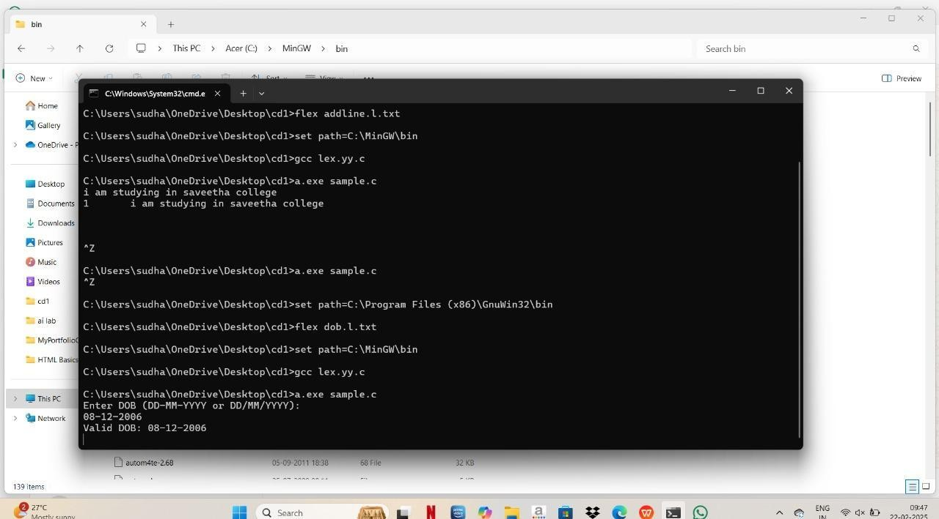

1. Write a LEX program to check whether the given input is digit or not.

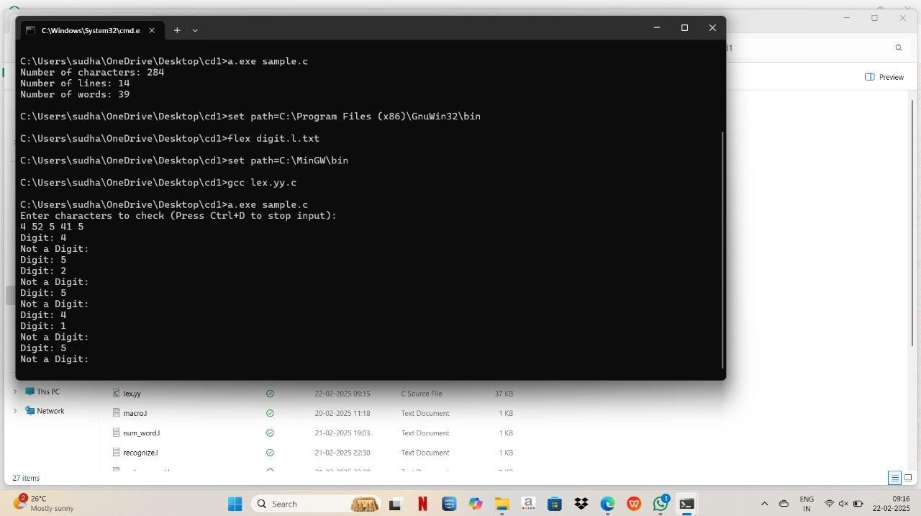

1. A School student was asked to do basic mathematical operations. Implement a LEX program to implement the same.

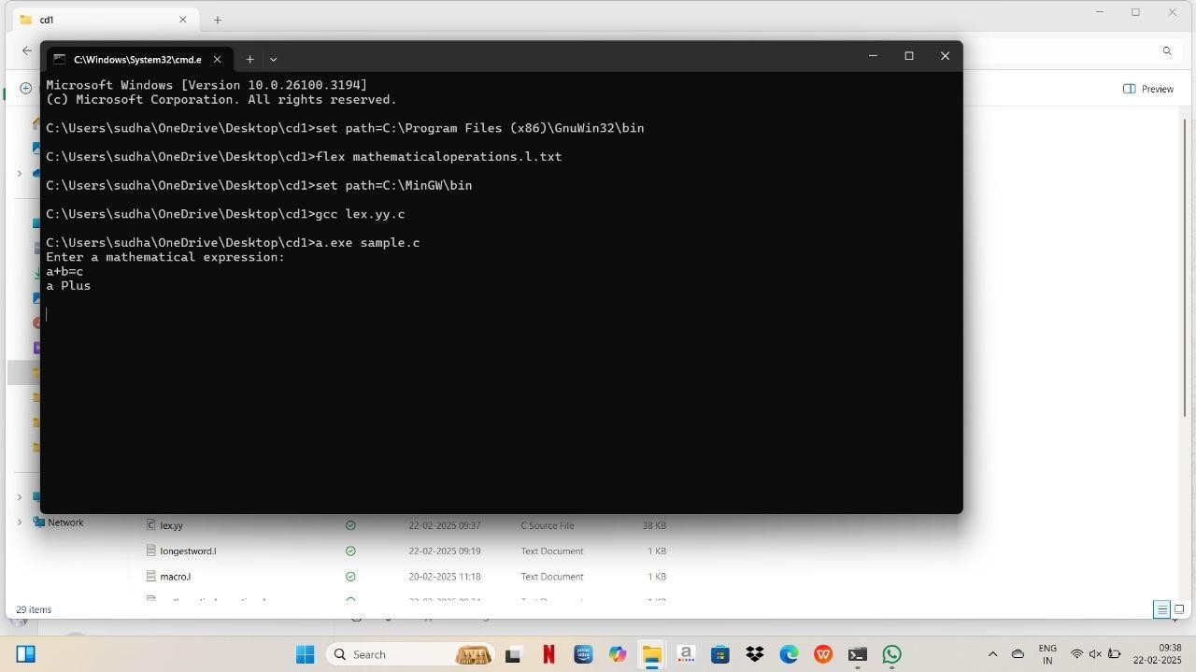

1. Write a [LEX program to accept string starting with vowel](https://copyprogramming.com/howto/what-s-the-difference-between-flex-start-and-baseline).

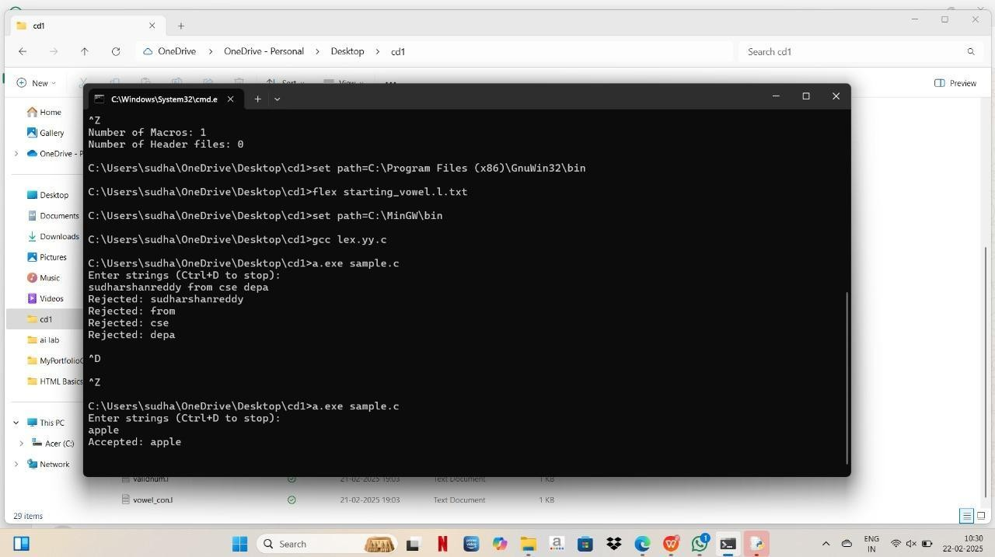

1. Write a LEX [program to find the length of the longest](https://copyprogramming.com/howto/python-find-longest-orf-in-dna-sequence) word

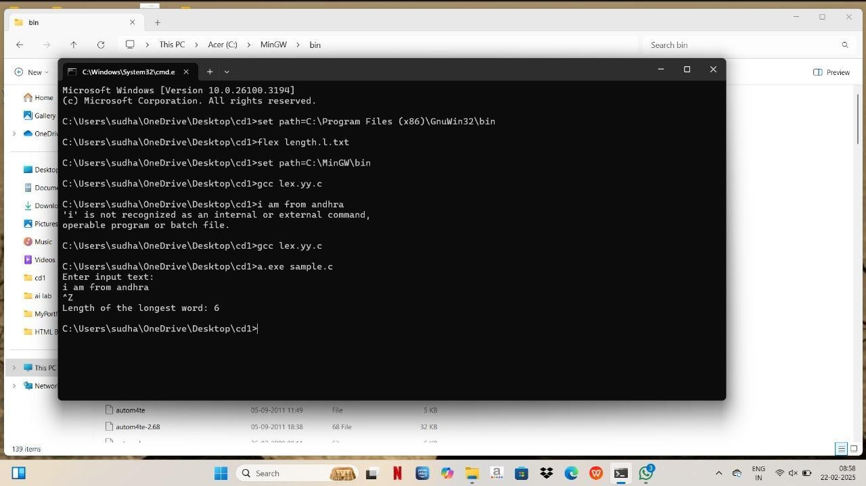

1. Write a LEX program to

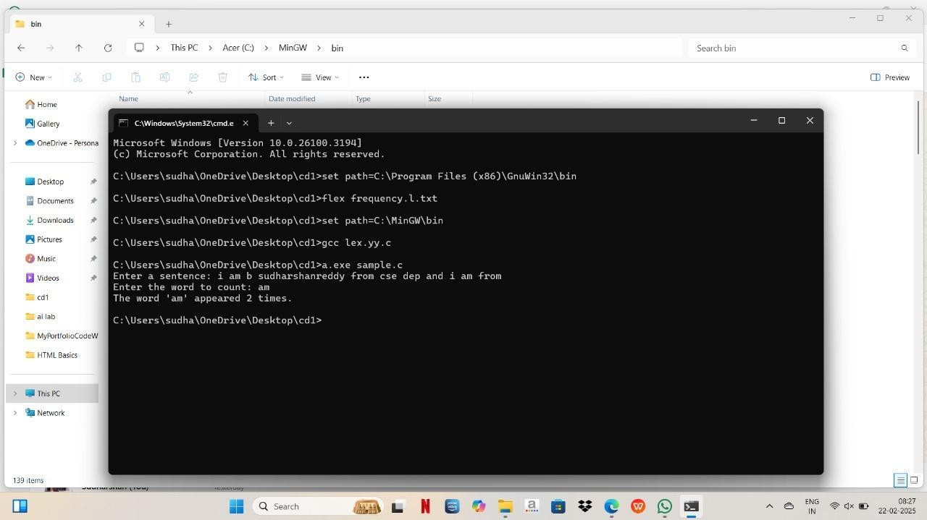 count the frequency of the given word in a given sentence.

1. Write a LEX code to replace a word with another word in a file.

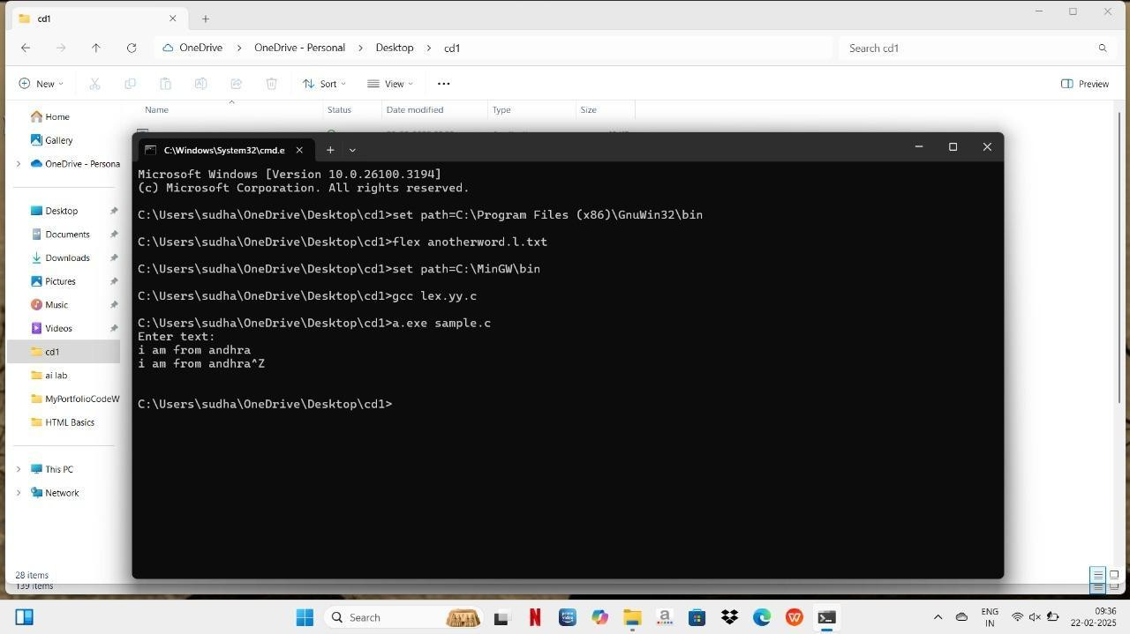

1. 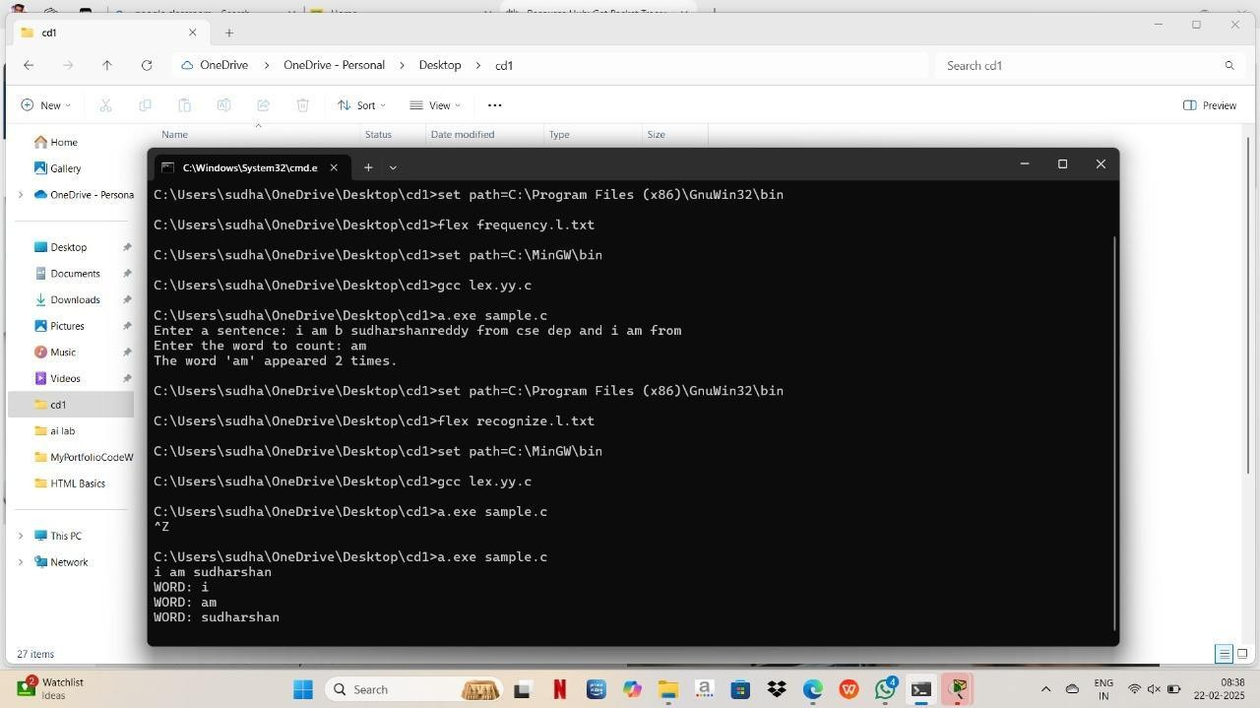Write a LEX program to recognize a word and relational operator.